Twitter Stock Market Analysis

df = pd.read_excel('/content/TWTR.xlsx')

# Convert Date column to datetime
df['Date'] = pd.to_datetime(df['Date'])

df.head()
Task 1: Data Analysis
1. Read the data and display the first 100 rows from the data:
Ans: df.head(100)
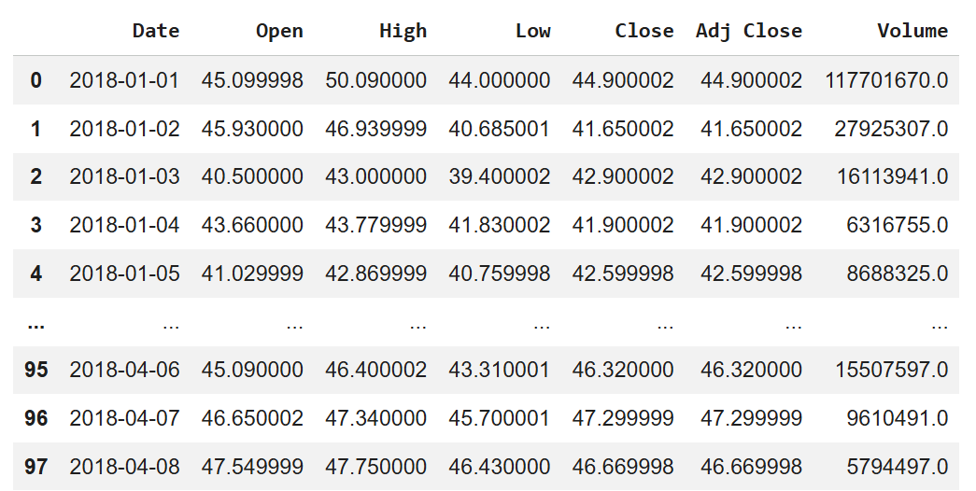
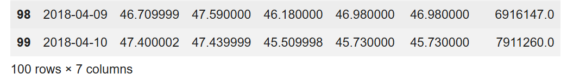
2. Give the column insights:
Ans: # Column information
df.info()

# Statistical summary
df.describe()
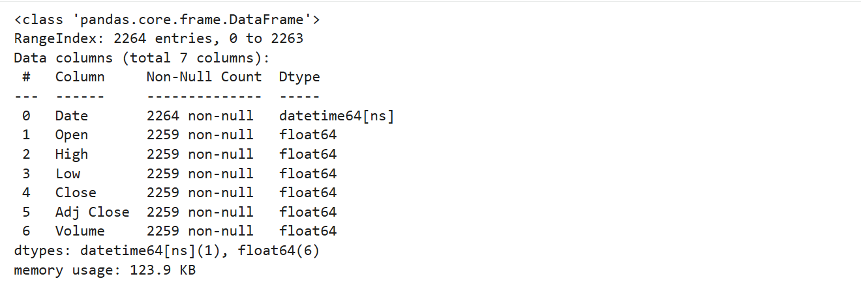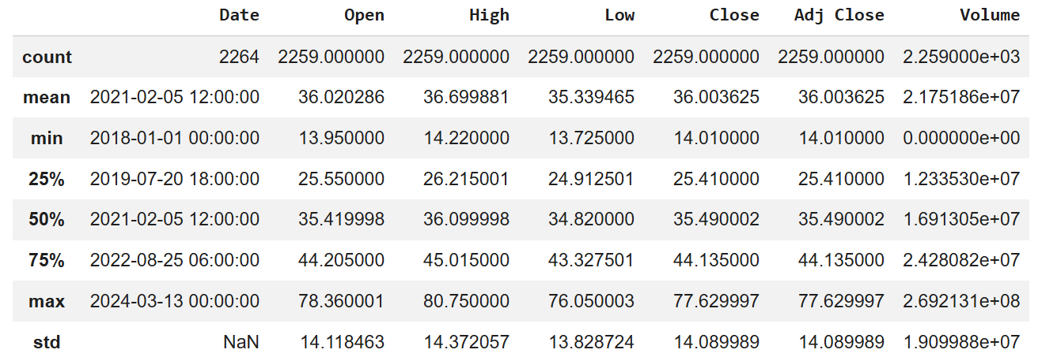
3. Check whether this dataset contains any null values or not; if there are any, then remove the null values:
Ans: df.isnull().sum()
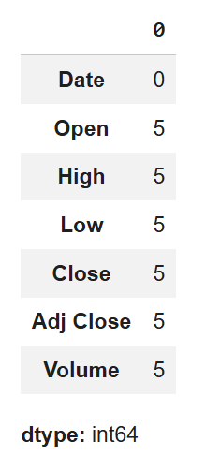
4. Find the statistical description of the data:
Ans: df.describe(include='all')
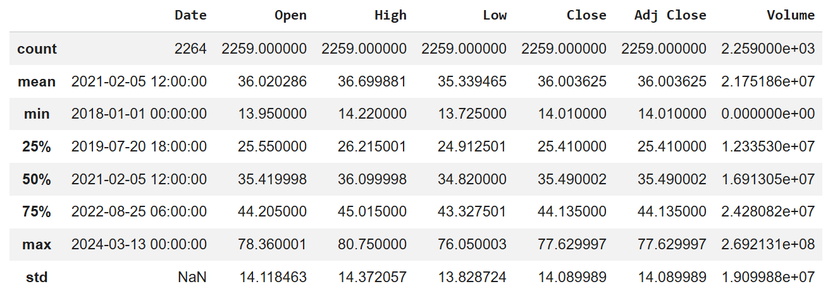
5. Find the missing values in the data:
Ans: # Total missing values
df.isna().sum()

# Percentage of missing values
(df.isna().sum() / len(df)) * 100
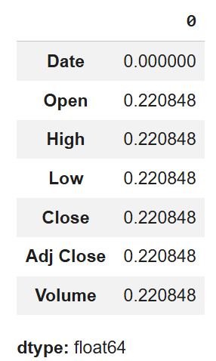
Task 2: Statistical Tests and Analysis (Optional)
1. Give me the Z-test or T-test over High, Low, and Close columns and see if the null hypothesis gets rejected or accepted:
Ans: # T-test between High and Low
t_stat_1, p_val_1 = stats.ttest_ind(df['High'], df['Low'])

# T-test between High and Close
t_stat_2, p_val_2 = stats.ttest_ind(df['High'], df['Close'])

# T-test between Low and Close
t_stat_3, p_val_3 = stats.ttest_ind(df['Low'], df['Close'])

t_stat_1, p_val_1, t_stat_2, p_val_2, t_stat_3, p_val_3
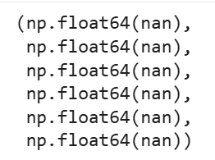
alpha = 0.05
print("Reject Null Hypothesis" if p_val_1 < alpha else "Accept Null Hypothesis")
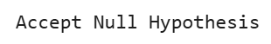
2. Check if the data is dependent or independent by using the chi-square method:
Ans: # Create categorical bins
df['Volume_cat'] = pd.qcut(df['Volume'], q=4)
df['Close_cat'] = pd.qcut(df['Close'], q=4)

# Contingency table
contingency_table = pd.crosstab(df['Volume_cat'], df['Close_cat'])

# Chi-square test
chi2, p, dof, expected = stats.chi2_contingency(contingency_table)

chi2, p
3. Write the insights which you have got from the above tests:
Ans: if p < 0.05:
print("Data is dependent")
else:
print("Data is independent")
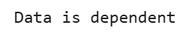
Task 3: Visualization and Analysis
1. Show the Twitter stock prices over the years and give a conclusion:
Ans: plt.figure(figsize=(12,6))
plt.plot(df['Date'], df['Close'])
plt.title('Twitter Stock Price Over Time')
plt.xlabel('Year')
plt.ylabel('Close Price')
plt.show()
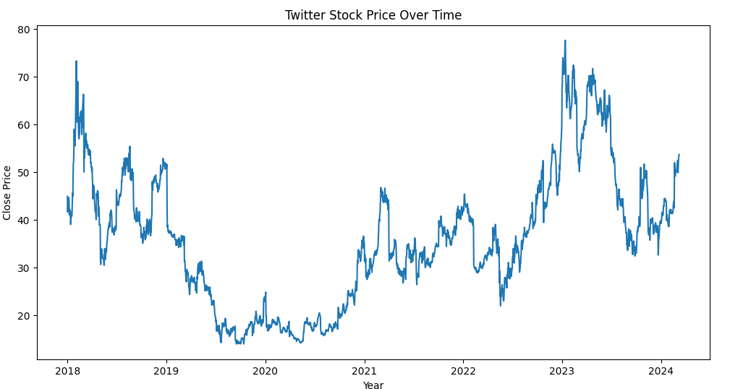
2. Compare the Close vs Date column for Twitter prices over the years:
Ans: sns.lineplot(x='Date', y='Close', data=df)
plt.title('Close Price vs Date')
plt.show()
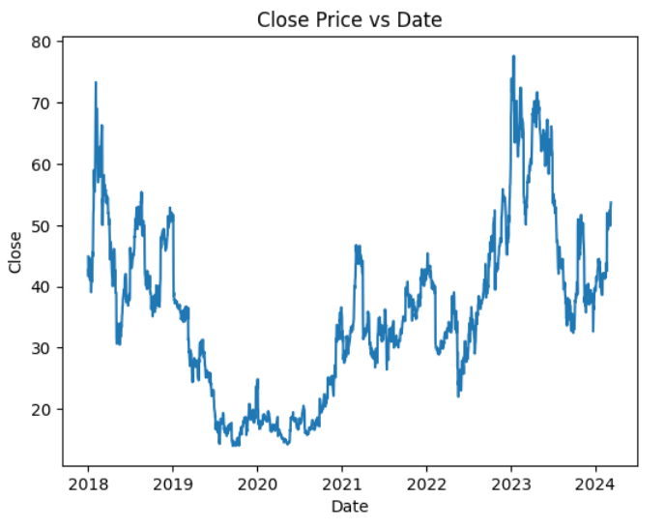
3. Assign buttons to control time periods. Add the buttons to analyze the stock prices of Twitter in different time periods:
Ans: fig = px.line(df, x='Date', y='Close', title='Interactive Twitter Stock Price')
fig.show()
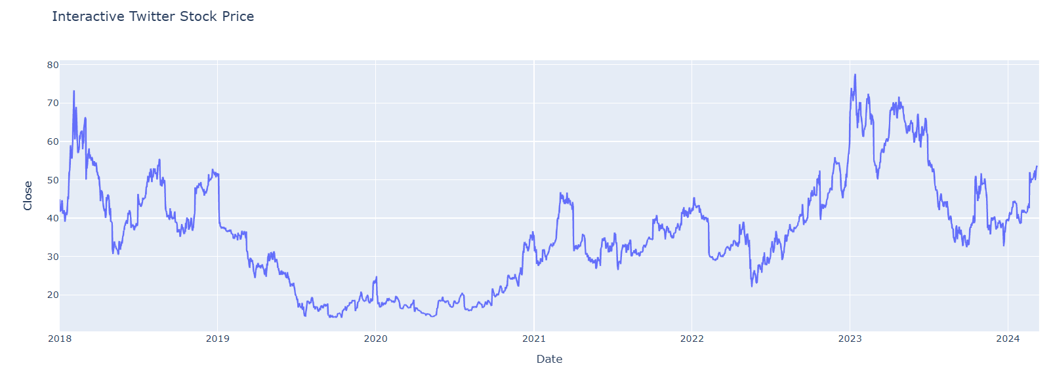
4. Give the complete timeline of Twitter in the stock market (Line Graph):
Ans: plt.figure(figsize=(14,7))
plt.plot(df['Date'], df['Adj Close'], color='green')
plt.title('Complete Twitter Stock Market Timeline')
plt.xlabel('Date')
plt.ylabel('Adjusted Close Price')
plt.show()
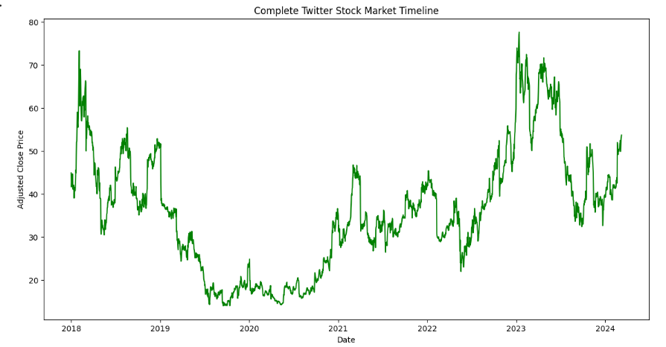
5. Give the insights for the above analysis and make a word cloud for that analysis:
Ans: from wordcloud import WordCloud

text = "Twitter Stock Market Volatility Growth Decline Acquisition Delisting"

wordcloud = WordCloud(width=800, height=400, background_color='white').generate(text)

plt.imshow(wordcloud)
plt.axis('off')
plt.show()


6. Create a Dashboard from the above statements by using Power BI, Tableau, or Python and present it to the Client:
Ans: fig = go.Figure()

fig.add_trace(go.Scatter(x=df['Date'], y=df['Close'], name='Close'))
fig.add_trace(go.Scatter(x=df['Date'], y=df['High'], name='High'))
fig.add_trace(go.Scatter(x=df['Date'], y=df['Low'], name='Low'))

fig.update_layout(title='Twitter Stock Dashboard',
xaxis_title='Date',
yaxis_title='Price')

fig.show()